1/17/2023

**QA Test Report**

Submited By Muhammad Atif Niaz

Contents

**1.** **Make the command ng test work** 2

**1.1.** **Ng Test Report** 2

**2.** **Check if the required features are correct implemented** 2

**2.1.** Wrong image detail page open. 2

**2.2.** **Last Image, detail page is not open.** 3

**2.3.** **Wrong image number displayed on detail page.** 4

**2.4.** **Back link available of detail of detail page instead of Back button.** 4

**2.5.** **Image is open on browser instead of direct download** 4

**2.6.** **All download links are active.** 5

**3.** **write the necessary missing test scripts** 5

**3.1.** **Total 11 Specs 3 Failures.** 5

**3.2.** **Total 11 Specs 1 Failures.** 6

**3.3.** **Total 11 Specs 0 Failures.** 6

**4.** **Make at least one end to end test using cypress** 7

**4.1.** **Test Case 01: Verify Gallery Listing Page** 7

**4.2.** **Test Case 02: Verify Picture Details Page** 7

**4.3.** **Test Case 03: Verify Download Form Picture Detail Page.** 7

**4.4.** **Test Case 04: Verify Back Link Form Picture Detail Page.** 7

**4.5.** **Test Case 05: Verify Download Form Gallery Listing Page.** 7

Requirements for the QA test

# **Make the command ng test work**

**First Run Server**

|  |
| --- |
| npm start |

**Then run ng test**

|  |
| --- |
| npm test |

## **Ng Test Report**

**Total 11 Specs 3 Failures.**

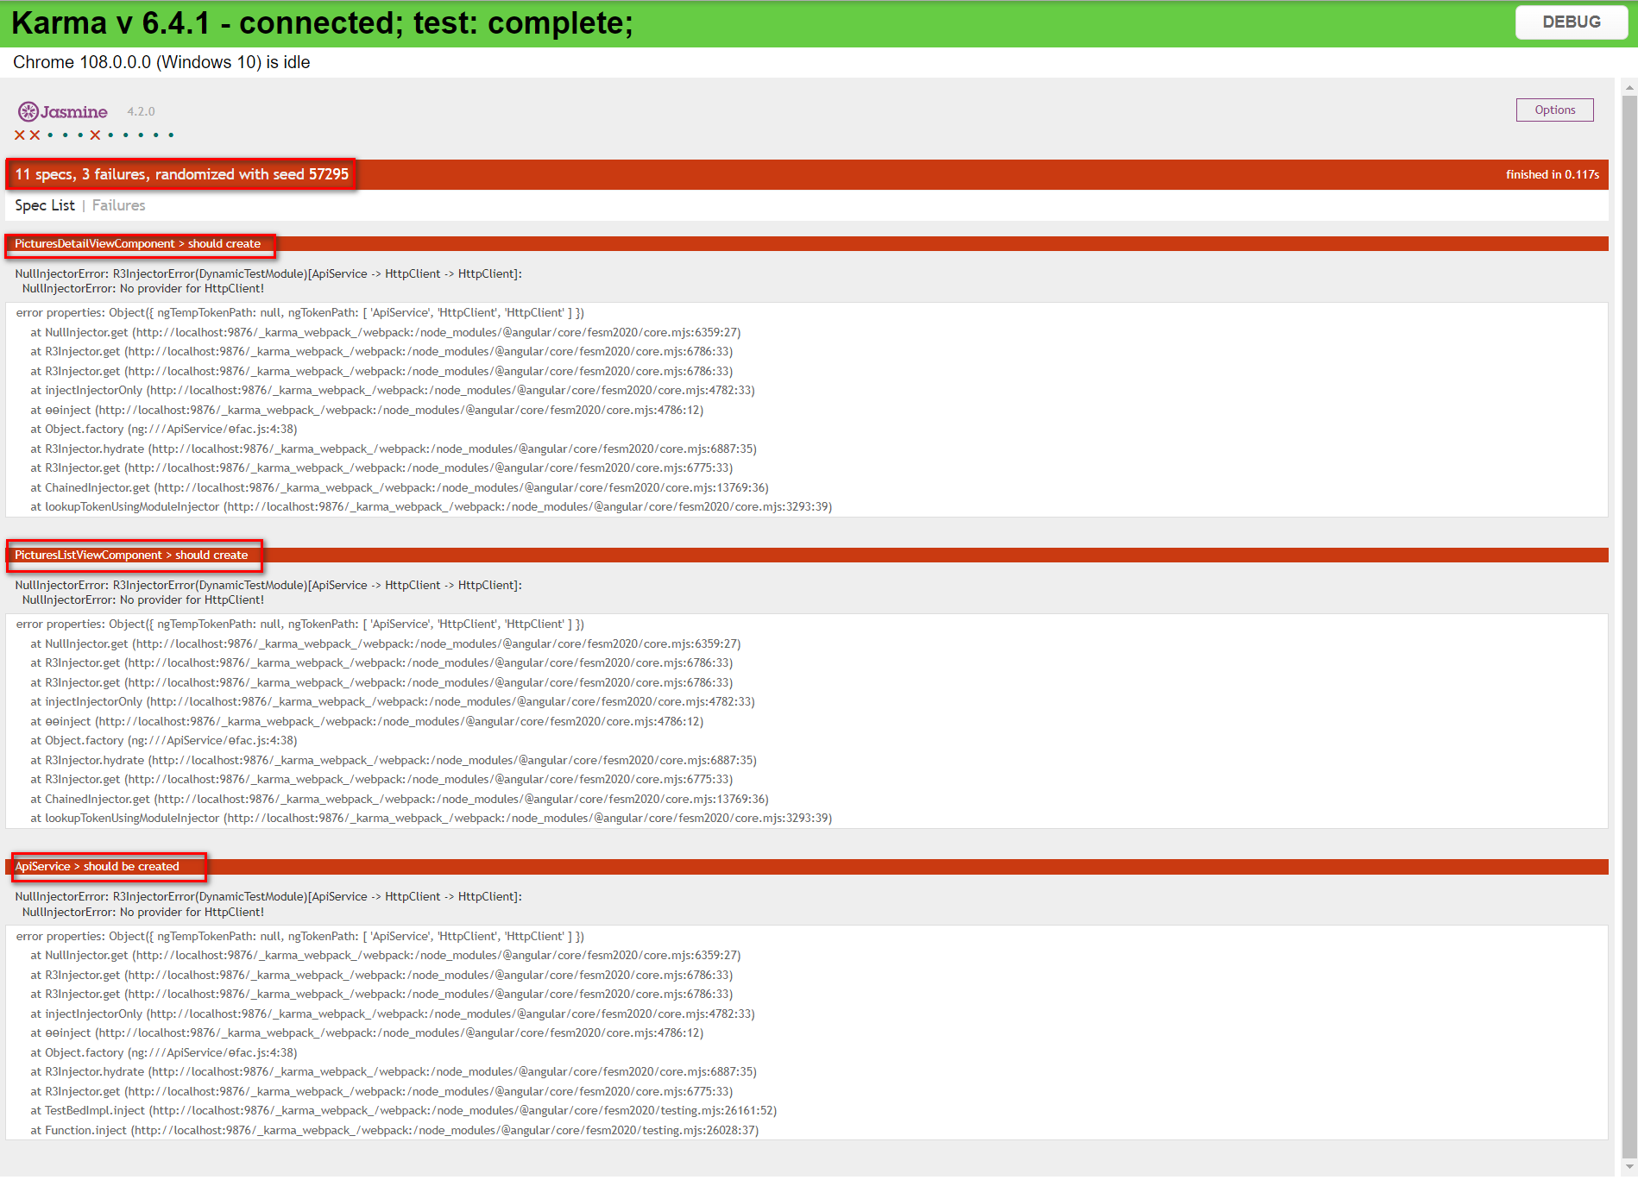

# **Check if the required features are correct implemented**

## Wrong image detail page open.

**For Example,** when we click on image 10 but image 11 details page is opened, snap shot attached for reference.

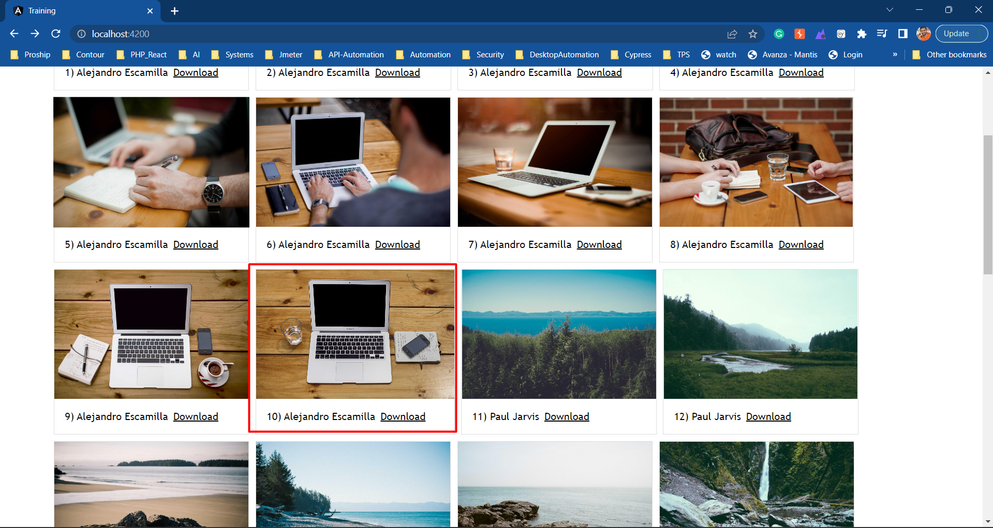

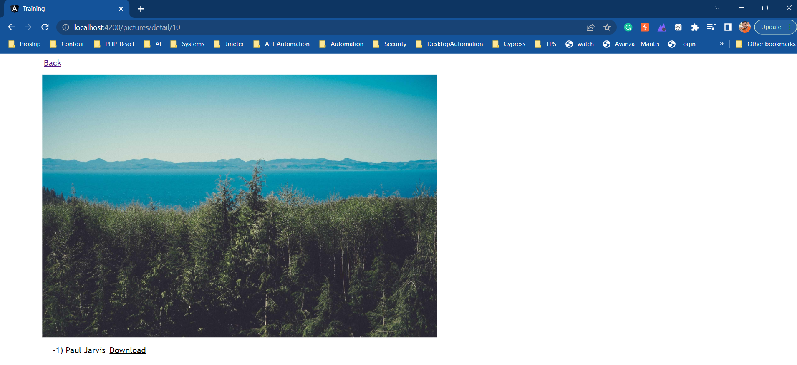

## **Last Image, detail page is not open.**

snap shot attached for reference.

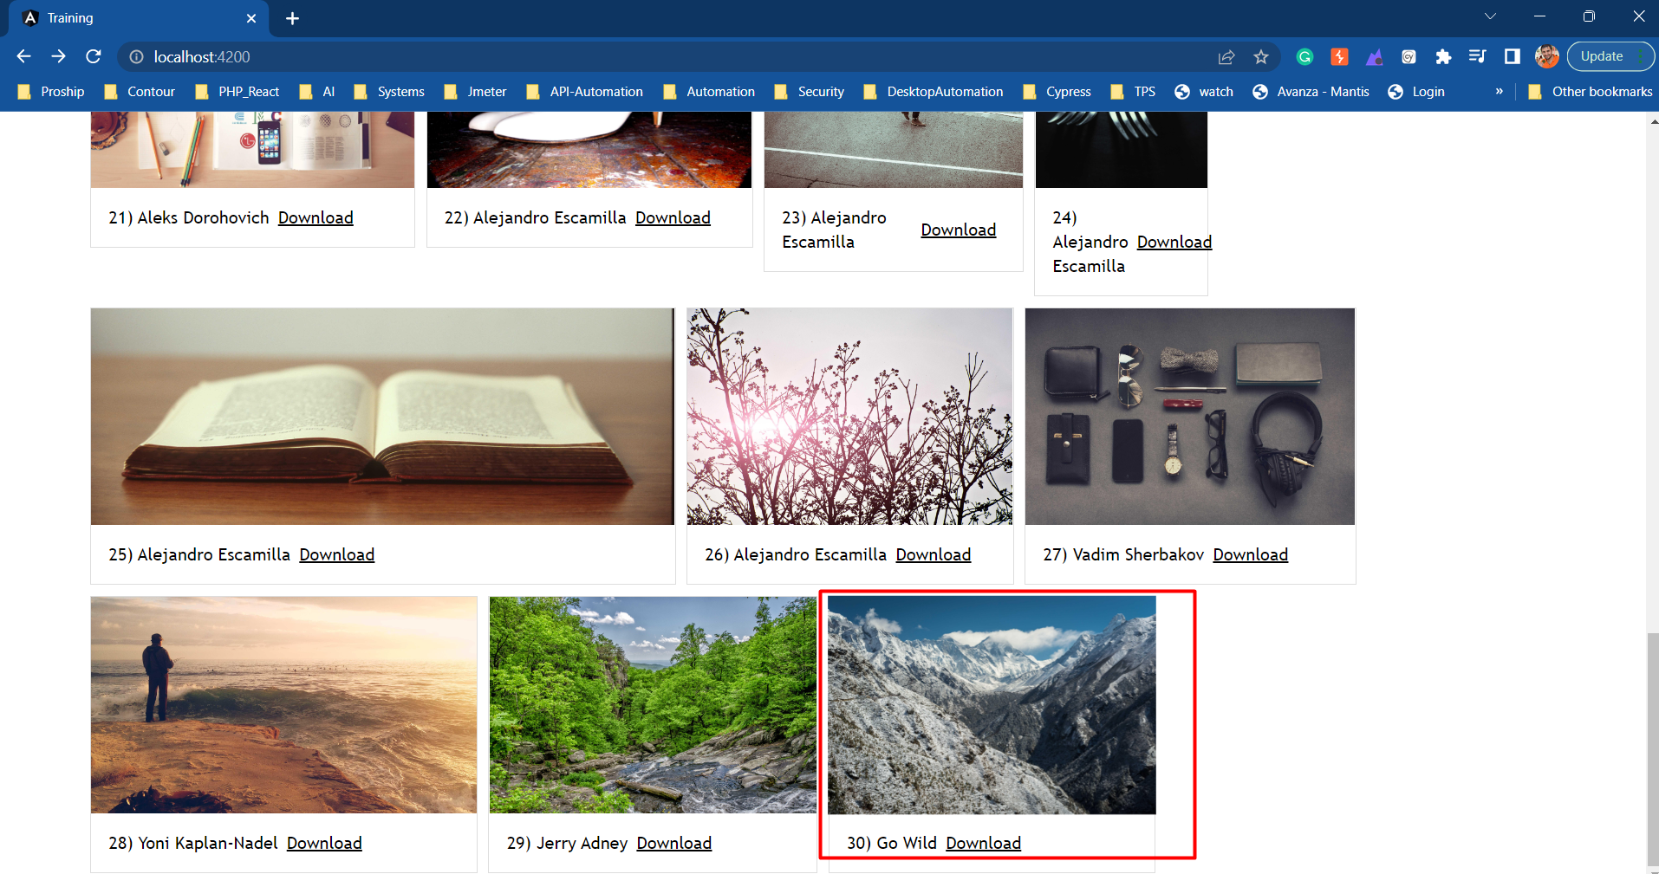

## **Wrong image number displayed on detail page.**

This issue happen for all images .Snap shot attached for reference.

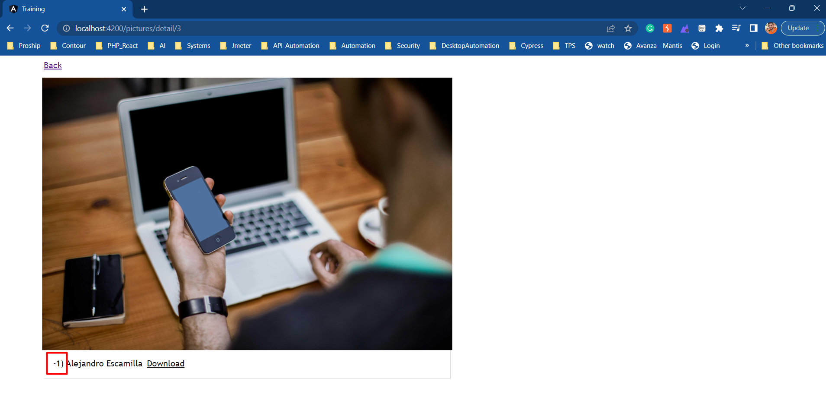

## **Back link available of detail of detail page instead of Back button.**

As per requirement “A **back button** will allow users to return to the gallery view “, snap shot attached for reference.

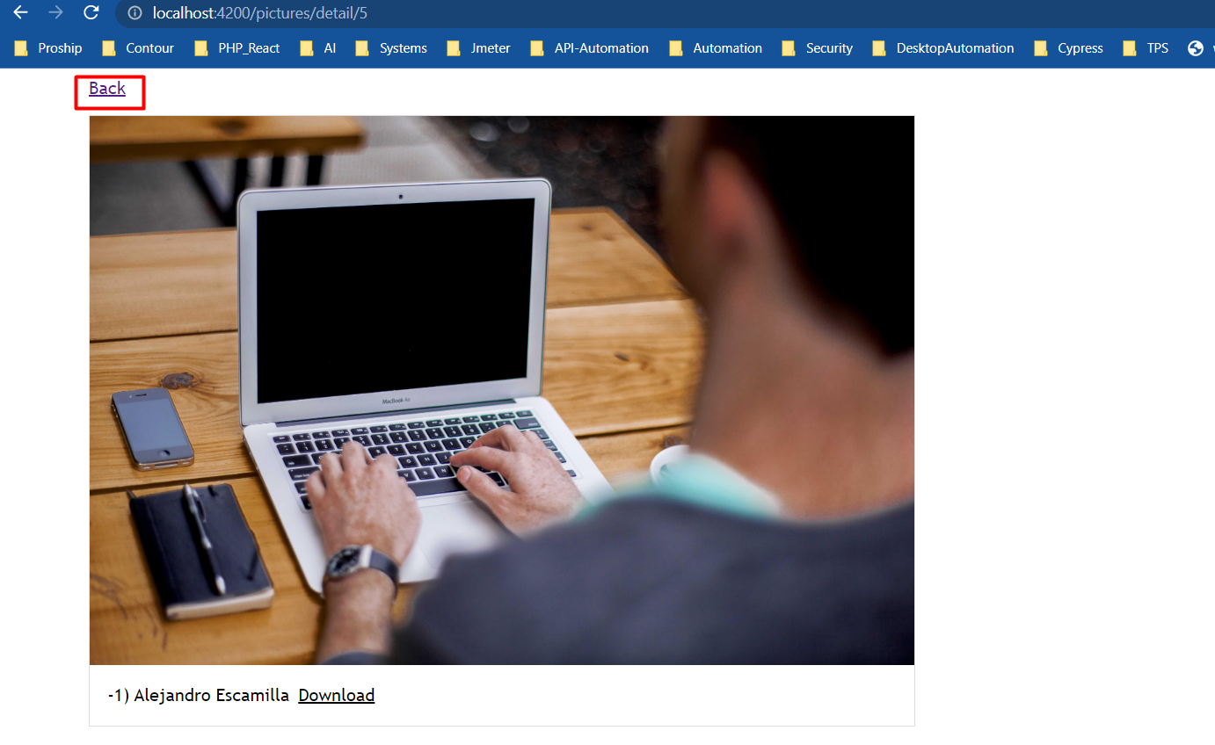

## **Image is open on browser instead of direct download**

When user click on download from (listing/detail page) Image is open on browser instead of direct download image. Snap shot attached for reference.

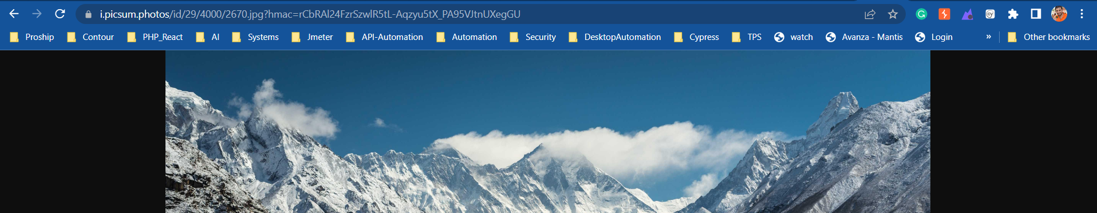

## **All download links are active.**

As per requirement” The download link is active only if the image has at least 4 Megapixel (4 x 106 pixel) and the width, respectively **height** have min 2000px.” **Example:** Some image height is less than 2000 px, snap shot attached for reference.

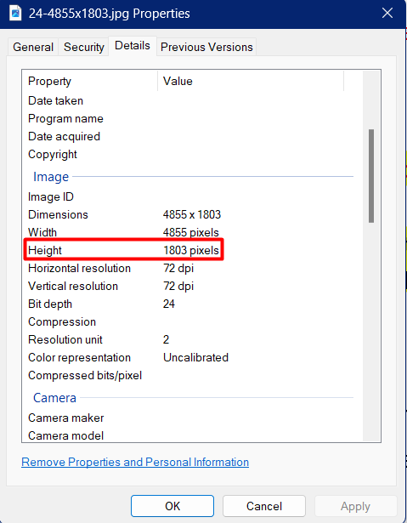

# **write the necessary missing test scripts**

## **Total 11 Specs 3 Failures.**



Doing Following changes in Following files:

1. pictures-detail-view.component.spec.ts
2. pictures-list-view.component.spec.ts
3. api.service.spec.ts

|  |
| --- |
| import { HttpClientTestingModule} from '@angular/common/http/testing'; |

Add below code in **‘beforeEach’ 🡪 TestBed.configureTestingModule**

|  |
| --- |
| imports: [HttpClientTestingModule,], |

**Then run ng test**

|  |
| --- |
| npm test |

## **Total 11 Specs 1 Failures.**

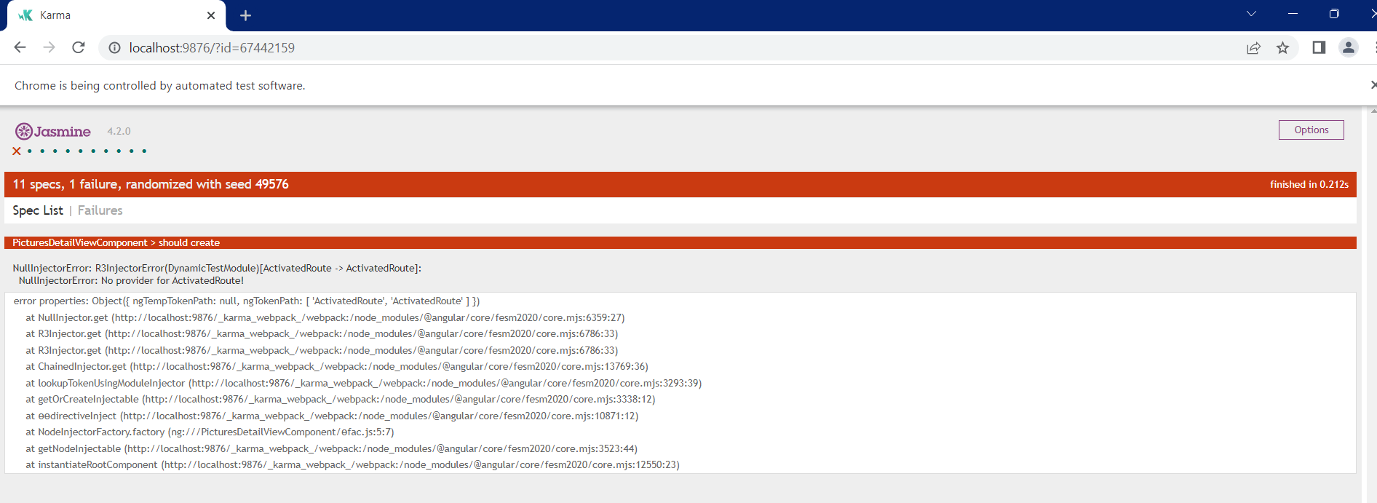

Doing Following changes in files ‘**pictures-detail-view.component.spec.ts**’

|  |
| --- |
| import { RouterTestingModule } from "@angular/router/testing"; |

Add below code in **‘beforeEach’ 🡪 TestBed.configureTestingModule**

|  |
| --- |
| imports: [HttpClientTestingModule,RouterTestingModule], |

**Final Report**

## **Total 11 Specs 0 Failures.**

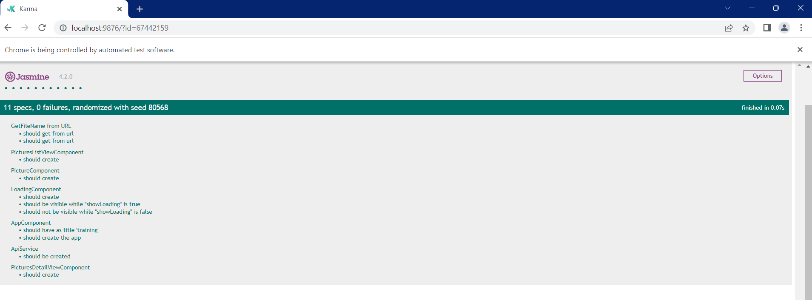

# **Make at least one end to end test using cypress**

|  |
| --- |
| **Note: we update the code for wrong image opened on detail page .Doing changes in ‘pictures-list-view.component.html’**  **Before**   <app-picture [picture]="picture" [index]="index+1" (click)="showDetails(index+1)"></app-picture>  **After:**  <app-picture [picture]="picture" [index]="index+1" (click)="showDetails(index)"></app-picture> |
| **Note: we make testcase in 2 different suites**   1. **One for Only single image. That name is “Verify Single Picture”** 2. **Second for All image verify that is available on listing page. That name is “Verify All Pictures”** |

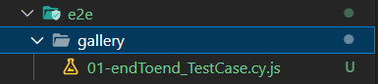

## **Test Case 01: Verify Gallery Listing Page**

* + 1. verify that **Total picture count in heading should be visible and it contain 30.**
    2. verify that **Total Downloads link should be 30.**
    3. verify that **Total author names should be 30**.

## **Test Case 02: Verify Picture Details Page**

* + 1. Verify that picture detail page should be open **URL contain '/pictures/detail/'.**
    2. Verify that author name should be same as **author name against picture on Gallery Listing page.**
    3. Verify that picture number should be same as picture number against picture on Gallery Listing page. **(Failed – Note now we Commit this line.)**
    4. Verify that **Download link available**.
    5. Verify that **Back link available.**

## **Test Case 03: Verify Download Form Picture Detail Page.**

* + 1. Verify that **correct picture is opened, Verify through URL.**

## **Test Case 04: Verify Back Link Form Picture Detail Page.**

* + 1. Verify that click on **Back user redirect to Gallery Listing Page**.

## **Test Case 05: Verify Download Form Gallery Listing Page.**

* + 1. Verify that **correct picture is opened, Verify through URL**.

**packages**, we used:

|  |
| --- |
| "cypress": "^12.3.0",  "cypress-mochawesome-reporter": "^3.2.3"  "@cypress/xpath": "^2.0.3" |

**Used Design Pattern:** Page Object Module

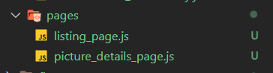

**For Execution of script:**

|  |
| --- |
| npx Cypress run --spec 'cypress\e2e\gallery\01-endToend_TestCase.cy.js' --browser 'chrome' |

**OR**

|  |
| --- |
| npm run cy:run |

**CLI Report:**

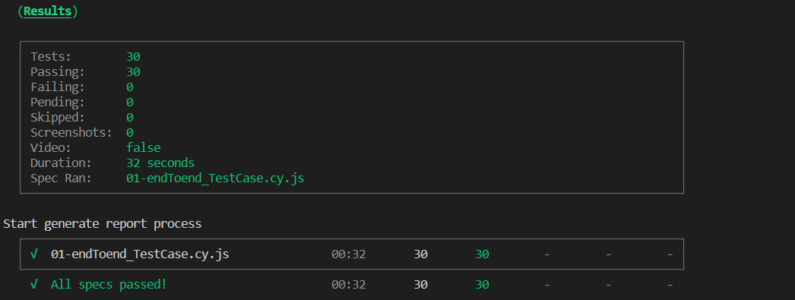

**Final HTML Report:**

